**Process design document**

**Level 0**

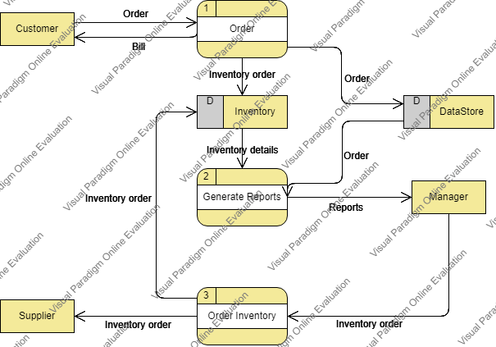

1. **Login processing:**

Login

Error

notification.

Manager

Staff

Check information

True

False

1. **Change password proccessing:**

Change

Error notification

Check infomation

True

False

Insert old password/ new password/confirm password.

Update database

1. **Manager processing**

Manage

Staff

View

Add

Edit

Block

Database

Customers

Products

View

Search

Add,Edit,Delete

Suppliers

View

View

Add

Edit

Delete

Categories

View

Add

Edit

Delete

Invoice

InputOrders

View

Add

Edit

Delete

View

1. **Staff Proccessing**

Staff

Database

Invoice

Products

Customers

View

Add

Edit

Block

View

Add

View

Filter

Search

Input Order

View